**Hritik Bansal**

**CSE A 15**

**180905105**

**IT LAB WEEK5**

**Q2)**

**Formapp/template/basic.html**

<!DOCTYPE html>

<html lang="en" xmlns="http://www.w3.org/1999/xhtml">

<head>

<meta charset="utf-8" />

<title></title>

</head>

<body>

<script type="text/javascript">

function myfunc() {

var date1 = new Date(document.getElementById("dateofjoining").value);

var date2 = new Date();

var Difference_In_Time = date2.getTime() - date1.getTime();

var Difference_In_years = (Difference_In_Time / (1000 * 3600 * 24)) / 365;

if(Difference_In_years>=5)

document.getElementById("para1").innerHTML = "YES";

else

document.getElementById("para1").innerHTML = "NO";

}

</script>

<h3>Promotion Check</h3>

<form >

<label for="eid">Select Employee id</label>

<select name="eid" id="eid">

<option value="1001">1001</option>

<option value="1002">1002</option>

<option value="1003">1003</option>

<option value="1004">1004</option>

</select>

<br><br>

</form>

Enter Date of joining: <input type="text" id="dateofjoining">

<br>

<br />

<button onclick="myfunc()" style="background-color:greenyellow;color:black">Am I eligible for promotion?</button><br\>

<br /><br />

<p id="para1"></p>

</body>

</html>

**OUTPUT:**

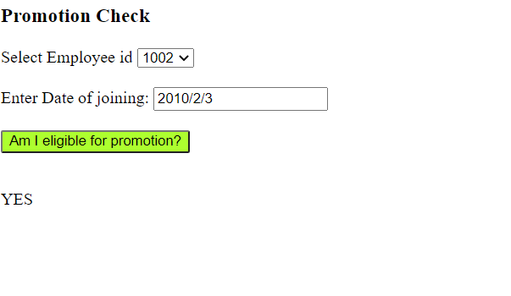

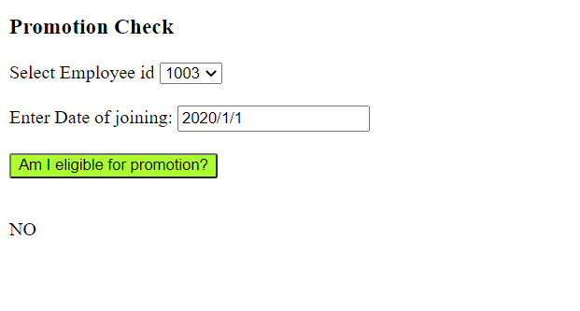

**Q3)**

**In views.py just change file name**

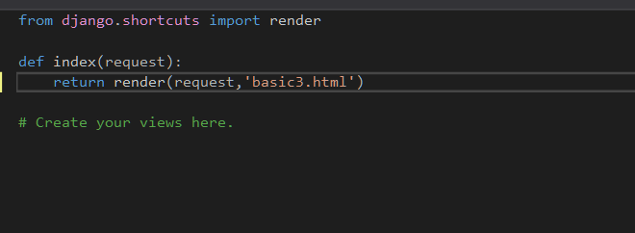

**Formapp\basic3.html**

<!DOCTYPE html>

<html lang="en" xmlns="http://www.w3.org/1999/xhtml">

<head>

<meta charset="utf-8" />

<title></title>

</head>

<body>

<script type="text/javascript">

function myfunc(){

var num1 = parseInt(document.getElementById("int1").value);

var num2 = parseInt(document.getElementById("int2").value);

var op = document.getElementById("op").value;

if (op.localeCompare("+") == 0)

document.getElementById("para1").innerHTML = num1 + num2;

else if(op.localeCompare("-") == 0)

document.getElementById("para1").innerHTML = num1 - num2;

else if(op.localeCompare("/") == 0)

document.getElementById("para1").innerHTML = num1 / num2;

else if(op.localeCompare("*") == 0)

document.getElementById("para1").innerHTML = num1 * num2;

else

document.getElementById("para1").innerHTML = num1 % num2;

}

</script>

Enter Integer1: <input type="text" id="int1"><br>

Enter Integer2 :<input type="text" id="int2"><br>

<form >

<label for="op">Enter Operand</label>

<select name="op" id="op">

<option value="+">+</option>

<option value="-">-</option>

<option value="/">/</option>

<option value="*">*</option>

</select>

<br><br>

</form>

<button onclick="myfunc()" style="background-color:cyan;color:black">Calculate</button><br\>

<br /><br />

<p id="para1"></p>

</body>

</html>

**OUTPUT:**

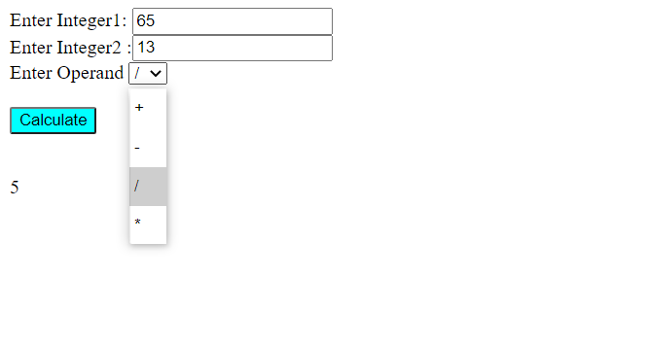

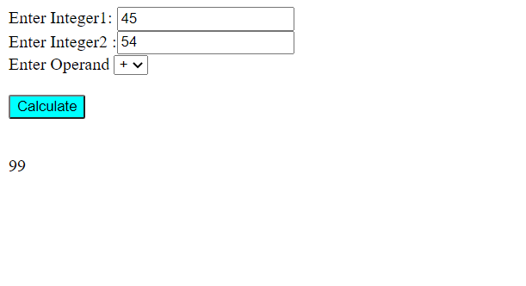

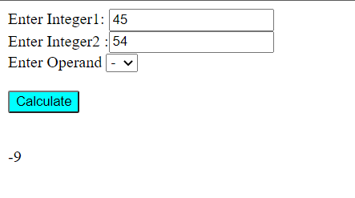

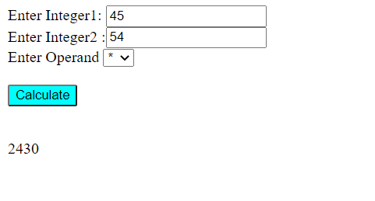

**Q4)**

**Basic.html**

<!DOCTYPE html>

<html>

<title>

Magazine Cover

</title>

<script src="https://ajax.googleapis.com/ajax/libs/jquery/3.5.1/jquery.min.js"></script>

<script>

$(document).ready(function(){

$("button").click(function(){

$("#divright").css("background-color",$("#bgcolor").val());

$("#greet").css("font-family",$("#fonttype").val());

$("#greet").css("font-size",parseInt($("#text1").val()));

if($("#None").is(":checked")){

$("#divright").css("border-style","None");

}

else if($("#Double").is(":checked") && $("#Solid").is(":checked")){

$("#divright").css("border-style","Double Solid",);

}

else if($("#Double").is(":checked")){

$("#divright").css("border-style","Double");

}

else if($("#Solid").is(":checked")){

$("#divright").css("border-style","Solid");

}

$("#greet").text($("#txarea1").val());

if($("#photo11").val()=="apple"){

$("img").attr("src", "https://i2.wp.com/ceklog.kindel.com/wp-content/uploads/2013/02/firefox_2018-07-10_07-50-11.png?w=641&ssl=1");

$("img").attr("width", "300px");

$("img").attr("height", "300px");

}

if($("#photo11").val()=="orange"){

$("img").attr("src", "https://5.imimg.com/data5/HM/KG/MY-42588315/fresh-orange-500x500.jpg");

$("img").attr("width", "300px");

$("img").attr("height", "300px");

}

});

});

</script>

<body>

<body>

<div id="divright" style="position: absolute; width: 400px; height: 700px;

right:100px; align-items: center">

<p id="greet" align="center"></p>

<img width=0px height=0px style="margin-left: 50px">

</div>

<div style="position: absolute; left: 100px">

<h1>Magazine Cover</h1>

<p1>Choose a bg color</p1>

<select id="bgcolor">

<option value="Red">Red</option>

<option value="Yellow">Yellow</option>

<option value="Blue">Blue</option>

</select>

<br></br>

<p1>Choose a font</p1>

<select id="fonttype">

<option value="Verdana">Verdana</option>

<option value="Times New Roman">Times New Roman</option>

</select>

<br></br>

<p1>Choose a font size</p1>

<input type="text" id="text1">

<p>Choose a border Style</p>

<input type="radio" id="None" value="None">

<label for="None">None</label><br>

<input type="radio" id="Double" value="Double">

<label for="Double">Double</label><br>

<input type="radio" id="Solid" value="Solid">

<label for="Solid">Solid</label>

<br>

<br>

<p1>Choose a picture</p1>

<select id="photo11">

<option value="apple">Apple</option>

<option value="orange">Orange</option>

</select>

<br></br>

<br>

<p1>Enter Magazine Headline</p1><br><br>

<input type="textarea" id="txarea1"><br><br>

<button>Update</button>

</div>

</body>

</html>

**OUTPUT:**

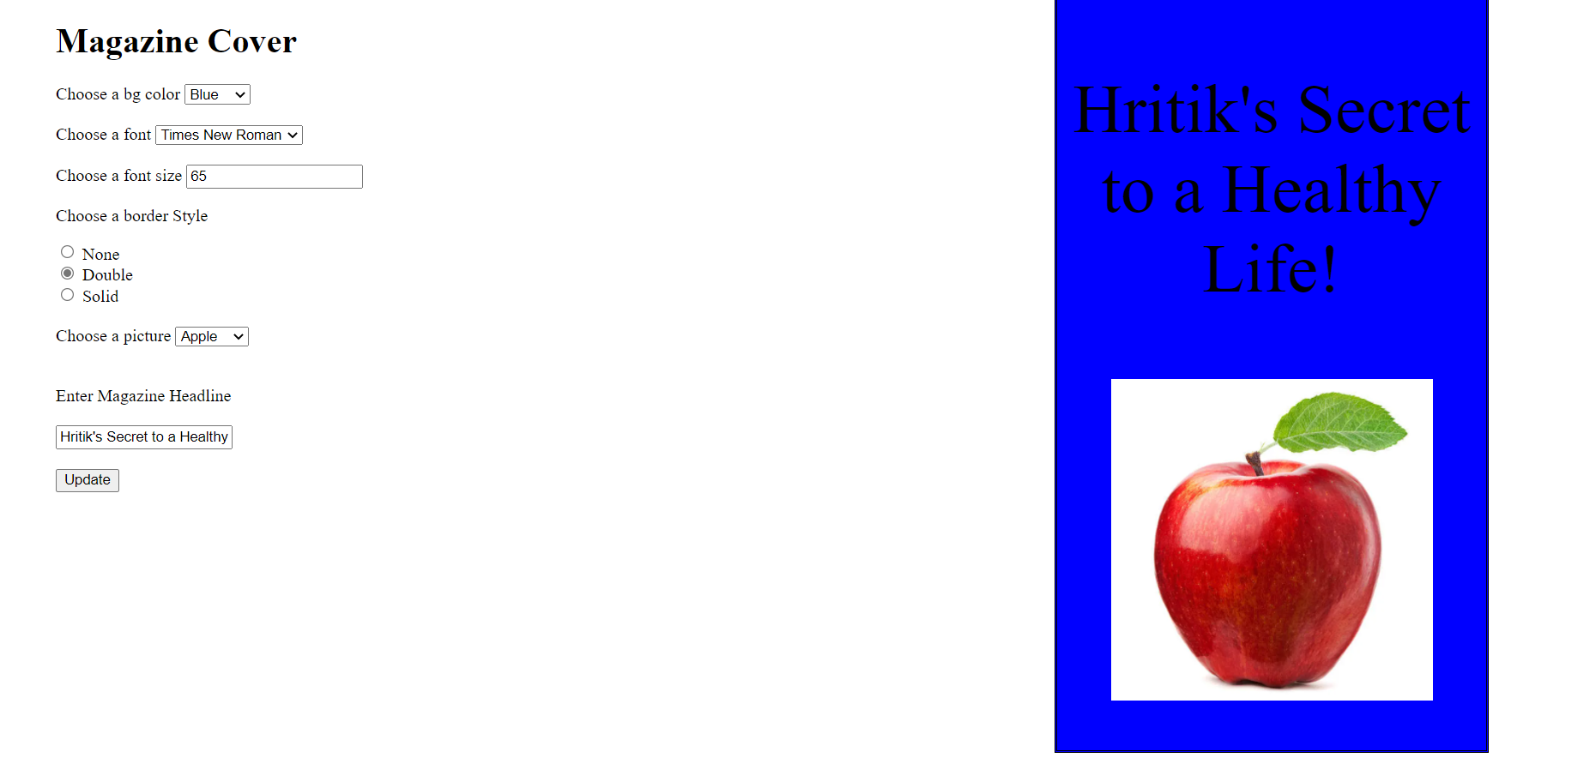

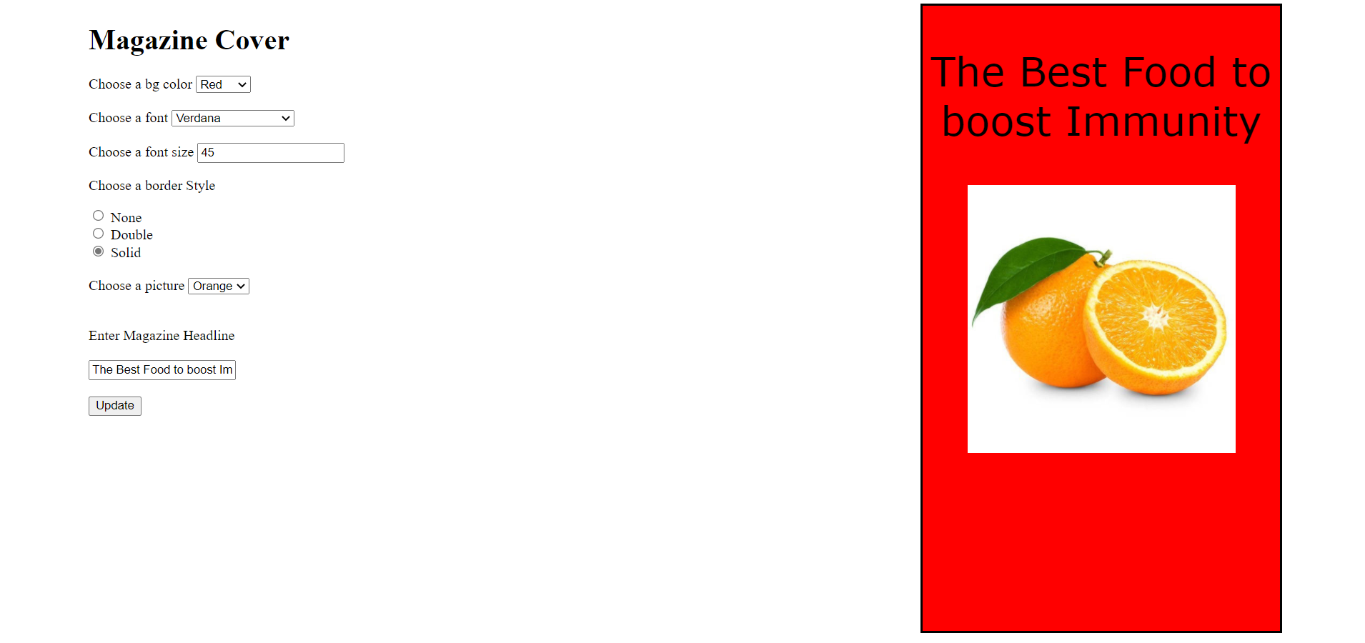

**ADDITIONAL 1)**

**FORMAPP/BSIC.HTML**

<!doctype html>

<html>

<head>

<meta charset="utf-8">

<title>Captcha</title>

</head>

<body>

<script type="text/javascript">

var wrong = 0;

function myfunc() {

var txt = document.getElementById("inp").value;

if (txt == "qGphJD")

document.getElementById("result1").innerHTML = "Success";

else {

document.getElementById("result1").innerHTML = "Failure";

wrong++;

if (wrong > 3)

document.getElementById("inp").disabled = true;

}

}

</script>

<div style="position:relative; line-height:2em; margin:50px;">

<img src="https://www.pandasecurity.com/en/mediacenter/src/uploads/2014/09/avoid-captcha.jpg"><br>

<input type="text" id="inp" placeholder="Enter text here"><br>

<button id="submit" type="button" onclick="myfunc()">Check</button><br>

<label id="result1"></label>

</div>

</body>

</html>

**OUTPUT:**

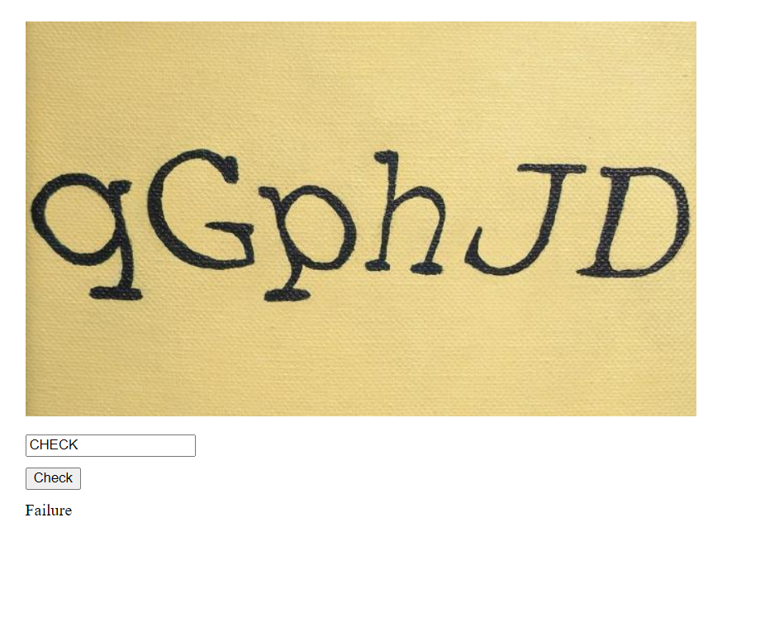

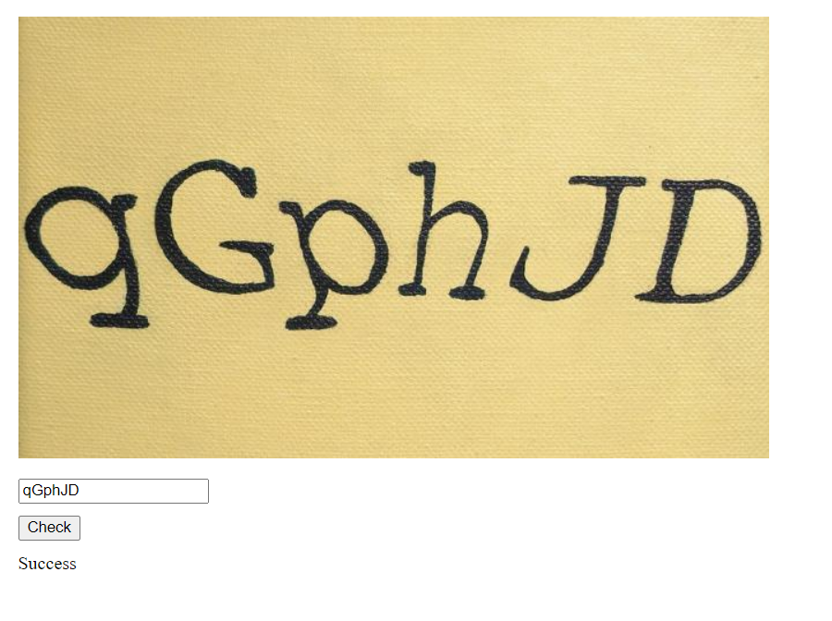

**ADDITIONAL 2)**

**Formapp\urls.py**

from django.conf.urls import url

from django.urls import path

from . import views

urlpatterns=[

path('', views.index, name='index'),

path('metadata/', views.metadata,name='metadata'),

path('reviews/', views.review,name='review'),

path('publisherinfo/', views.publisherinfo,name='publisherinfo'),

]

**Formapp\views.py**

from django.shortcuts import render

def index(request):

return render(request,'additional2.html')

def metadata(request):

return render(request,'metadata.html')

def review(request):

return render(request,'review.html')

def publisherinfo(request):

return render(request,'publisherinfo.html')

# Create your views here.

**projectname\urls.py**

from django.contrib import admin

from django.urls import path

from django.conf.urls import include, url

urlpatterns = [

# Uncomment the next line to enable the admin:

path('admin/', admin.site.urls),

path('',include('formapp.urls')),

]

**Formapp\templates\additional2.html**

<!doctype html>

<html>

<head>

<meta charset="utf-8">

<title>Book</title>

</head>

<body>

<h3>Harry Potter</h3>

<div id="div1" style="position:relative; line-height:2em; margin:70px;">

<img id="1" src="https://images-eu.ssl-images-amazon.com/images/I/51ifu1aebKL._SY264_BO1,204,203,200_QL40_FMwebp_.jpg" height="400px"><br>

<ul>

<li><a href="./metadata">Metadata</a></li>

<li><a href="./reviews">Reviews</a></li>

<li><a href="./publisherinfo">Publisher's Info</a></li>

</ul>

</div>

</body>

</html>

**Formapp\templates\metadata.html**

<!doctype html>

<html>

<head>

<meta charset="utf-8">

<title>Book - Metadata</title>

</head>

<body>

<h3>Metadata</h3>

<div id="div1" style="position:relative; line-height:2em; margin:70px;">

Author J. K. Rowling<br> Country United Kingdom<br> Language English<br> Publisher Scholastic, (UK)<br> Harcourt Brace (US)<br> Publication date 17 July 2001<br><br> Media type Print (hardback and paperback)<br>

<a href="..">Home</a>

</div>

</body>

</html>

**Formapp\templates\review.html**

<!doctype html>

<html>

<head>

<meta charset="utf-8">

<title>Book - Reviews</title>

</head>

<body>

<h3>Reviews</h3>

<div id="div1" style="position:relative; line-height:2em; margin:70px;">

<ol>

<li>

<p>Orphaned Harry Potter has been living a dog’s life with his horrible relatives. He sleeps in the broom cupboard under the stairs and is treated as a slave by his aunt and uncle. On his eleventh birthday, mysterious missives begin arriving for him, culminating eventually in the arrival of a giant named Hagrid, who has come to escort him to the Hogwarts School of Witchcraft and Wizardry. Harry learns that his parents died saving him from an evil sorcerer and that he himself is destined to be a wizard of great power. Harry’s astonished introduction to the life of wizardry starts with his purchase, under Hagrid’s guidance, of all the tools of an aspiring sorcerer: wand, robes, cauldron, broomstick, owl. Hogwarts is the typical British public school, with much emphasis placed on games and the honor of the Houses.</p>

</li>

<li>

<p>n this sequel to the phenomenally popular Harry Potter and the Sorcerer’s Stone, Harry returns to Hogwarts School of Witchcraft and Wizardry for his second year after a miserable summer with his Muggle (nonmagical) relatives. Once again, Harry’s school experiences are colored by encounters with genial ghosts and antagonistic teachers, by the rivalry between good-guy Gryffindor House and slimy Slytherin House, and by an ominous mystery to be solved involving Harry’s archenemy, the dark sorcerer Lord Voldemort. .</p>

</li>

</ol>

<a href="..">Home</a>

</div>

</body>

</html>

**Formapp\templates\publisherinfo.html**

<!doctype html>

<html>

<head>

<meta charset="utf-8">

<title>Book - Publisher's Info</title>

</head>

<body>

<h3>Publisher's Info</h3>

<div id="div1" style="position:relative; line-height:2em; margin:70px;">

After eight other publishers had rejected Philosopher's Stone, Bloomsbury offered Rowling a £2,500 advance for its publication.[54][55] Despite Rowling's statement that she did not have any particular age group in mind when beginning to write the Harry Potter books, the publishers initially targeted children aged nine to eleven.[56] On the eve of publishing, Rowling was asked by her publishers to adopt a more gender-neutral pen name in order to appeal to the male members of this age group, fearing that they would not be interested in reading a novel they knew to be written by a woman. She elected to use J. K. Rowling (Joanne Kathleen Rowling), using her grandmother's name as her second name because she has no middle name.[

<br><br>

<a href="..">Home</a>

</div>

</body>

</html>

**OUTPUT:**

